## North South Universiy



**Project Report for CSE215L**

**Project name: “Digital Hostel Management System”**

**Submitted by,**

**Md Tasbiul Hasan ID: 1821496042**

**& Md Saeem Hossain Shanto ID: 1912218642**

**Section: 12**

**Submission Date: 17-12-2019**

**Submitted to : Sayed Ibn Masud (Lab Instructor)**

**Introduction About “Digital Hostel Management System”**

“HOSTEL MANAGEMENT SYSTEM” is software developed for managing various activities in the hostel.. This particular project deals with the problems on managing a hostel and avoids the problems which occur when carried manually. PROBLEM DEFINITION This system is designed in favor of the hostel management which helps them to save the records of the students about their Monthly payment of living cost and Meal cost. It helps them from the manual work from which it is very difficult to find the record of the students and the mess all bills of the students, Count Food Meals and the information of about the those ones who had left the hostel. All the hostels at present are managed manually by the hostel office. This system automatically calculates all the bills and issued the notifications for those students who are against some rules. This software product the hostel management to improve their services for all the students of the hostel. This also reduce the manual work of the persons in admin penal. Through this you can check the personal profile of all the current students within few minutes the data base of the system will help you to check a particular one. The system will help you to check the mess all bills of every student and the student’s hostel dues. The students of the hostel will be recognized from the ID number allocated at the room rental time. In the last this system will improve the management work in the hostel.

Project structure:

* Project Name “Digital Hostel Management System**”**
* Packages:
* ManagerInfo
* Bills
* ManagerControl
* Rent_And_Room
* SearchUser
* SendBills
* Set_Bills_GUI
* Total_Bills
* TotalRent
* Meal
* DailyFoodOrder
* DailyMeal
* Grocery
* Meal_List_MakingGUI
* MonthMealChartGUI
* OrderMeal
* MemberInfo
* Controller
* Current_BillGUI
* Home
* Login
* LoginGUI
* Main
* Meal
* Member
* MemberInfoGUI
* MemberProfGUI
* MemberProfileGUI
* NecessityMeetException
* Normal_Meal
* OrderMeal
* RobotCheck
* SignUp
* SignUpException
* SignUpGUI
* SignUpGUI

**Features:**

* **Colorful Frame and UI for every part**
* **Login**
* **Security System**
* **Management Window**
* **Member Window**
* **Manager can handle all Function**
* **Handle All members Payment & Meal**
* **Save a Member information**
* **Member can show all the rent of Hostel Bills**
* **All person Total Bill management system(monthly)**
* **Show about all Hostel bills paid or due**
* **Chose Meal**

## Conclusion:

**We are trying to do a project that’s name “Digital Hostel Management System” that can help people to manage a hostel information easily. Member of hostel and Manager both can be benifitted with this App.  
We are trying to develop its more and more for better facilities.**

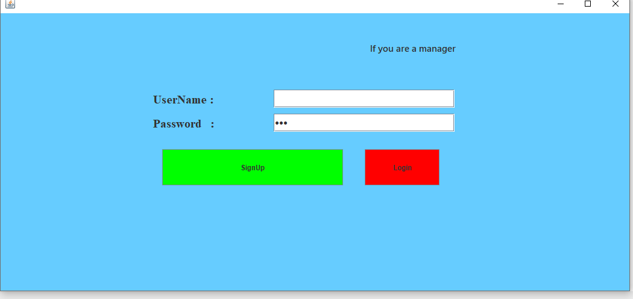

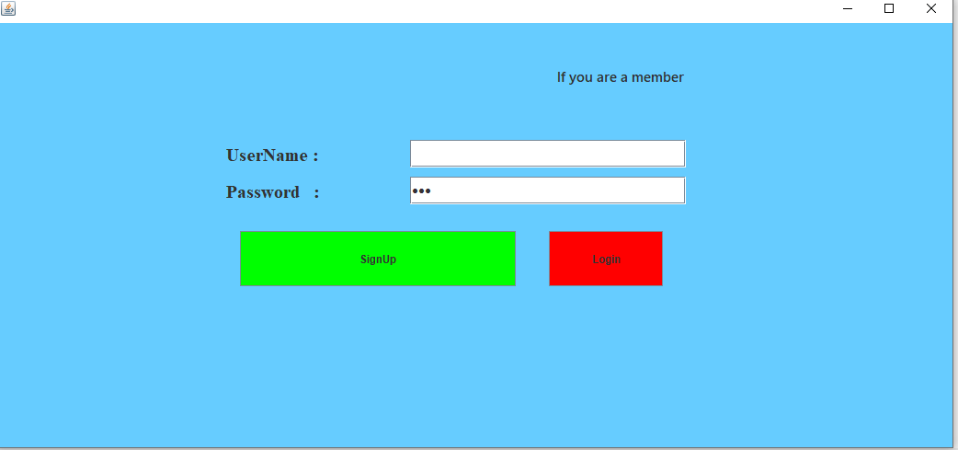

**Here, we are introducing our features with UI pictures:**

